What is APEX ?

- Apex is strongly type object oriented programming language which is proprietary language developed by salesforce.com to allow us to write the code that executes on the force.com platform

- It is used for building SAAS applications on the top of salesforce.com CRM functionality.

- Apex is saved , complied and executed on the servers of the force.com platform

Features of Apex
- It upgrades automatically.
- Integrated with the DB which means it can access and manipulate records without the need to establish the DB connection explicitly
- It has java like syntax and it is easy to use
- It is easy to test as it provides built in support for executing test cases.
- Multi-Tenant Environment
- You can save your apex code against different versions of the force.com API
- Apex is a case-insensitive language.

When to use Apex

- To perform a couple of business process which are not supported by workflows or process or flows
- To perform complex validation over multiple objects
- To create web services and email services
- For transactions and rollbacks

Flows of Action

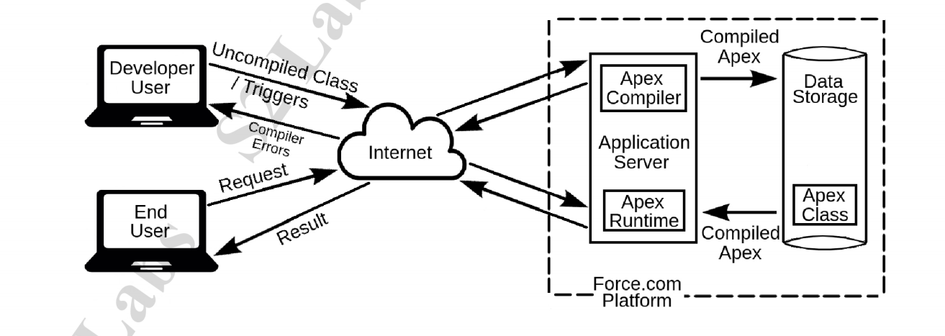
Features not supported by Apex

- It cannot show the elements in UI other than error message
- It cannot change the SFDC functionality but can be used to stop its execution or to add a new functionality
- It cannot be used to create a temporary file
- It cannot create multiple threads

Apex Environments

There are several environments for developing apex code
- We can run apex in a developer org , production org and a sandbox
- We cannot develop in our production org because live users are accessing the system so while we are devloping it can destabilize our data and corrupt our application.
- Instead we do all our development work in sandbox or developer edition.

Different tools for writing Apex

- Force.com Developer Console: The developer console is an integrated developer environment and collection of tools that we can use to create , debug and test applications in our salesforce org
- Code Editor in Salesforce Interface : This code editor complies all classes and triggers then they are some and flags the errors if they are any.

Note : The Code doesn’t get saved until it compiles without errors. The force.com developer console allows you to write , test and debug our Apex code . On the other hand the code editor in the interface enables only writing the code and does not support debugging or testing

Public class NewClass {

public static void myMethod(){
System.debug(‘ Hello Salesforce Devlopment’);

}

}

Apex Variables

A variable is a name value holder in memory. IN Apex local variables are declared with java-like syntax

The name we choose for a variable is called an identifier. Identifier can go any length but it must begin with an alphabet. The rest of the identifier can include digits also.

- Operators and spaces are not allowed
- We can’t use any of the apex reserved keywords when naming variables , method or classes
- Keywords are the words that are essential for Apex language

Integer i_a; OK
Integer _ia; Wrong
Integer ia_; Wrong
Integer i2 ; OK

Apex Constants
Apex Constants are the variables whose values don’t change after being initialized once.
Constants can be defined using the final keyword.
Constants can be assigned almost once either in the declaration itself or with a static initialization method , if the constant is defined in a class

Note : We cannot use final keyword in the declaration of a class or a method because in apex classes and methods are by default final and cannot be overridden or inherited without using the virtual keyword.

final integer a = 5;

Apex Literals
Integer I = 123;
String str =’123’;

Expressions

An expression is a combination made up of variables ,operators and method invocation that evaluates to a single value.

